**Supplemental material for the paper ‘Homicides in Mexico increased inequality of lifespans and slowed down life expectancy gains in 2005-2015‘**

**Authors:** Redacted

**Author affiliations:** Redacted

**Corresponding author:** Redacted

**Table 1. Classification of causes of death based on Aburto et al 2016**

|  |  |  |  |  |
| --- | --- | --- | --- | --- |
| **Category** | ICD 10 | | ICD 9 | |
| **I. Amenable to medical service** I.A. AM-Infectious & respiratory diseases : intestinal infections, tuberculosis, zoonotic bacterial diseases, other bacterial diseases, septicemia, poliomyelitis, measles, rubella, infectious hepatitis, ornithosis, rickettsioses/ arthropod-borne, syphilis (all forms), yaws, respiratory diseases, influenza & pneumonia, chronic lower respiratory diseases I.B. AM-Cancers: malignant neoplasm of colon, skin, breast, cervix, prostate, testis, bladder, kidney-Wilm’s tumor only, eye, thyroid carcinoma, Hodgkins disease, leukemia I.C. AM-Circulatory: active/acute rheumatic fever, chronic rheumatic heart disease, hypertensive disease, cerebrovascular disease I.D. AM-Birth: maternal deaths (all), congenital cardiovascular anomalies, perinatal deaths (excluding stillbirths) I.E. AM-Other: disease of thyroid, epilepsy, peptic ulcer, appendicitis, abdominal hernia, cholelithiasis & cholecystitis, nephritis, benign prostatic hyperplasia, misadventures to patients during surgical or medical care, cisticerchosis. | A00-A09, A16-A19, B90, A20-A26, A28, A32, A33, A35, A36, A37, A40-A41, A80, B05-B06, B15-B19, A70, A68, A75, A77, A50-A64, A66, J00-J08, J20-C50, C53, C61, C62, J39, J60-J99, J09-J18, J40-J47 C16,C18-C21, C43-C44, C67, C64, C69, C73, C81, C91-C95 I00-I02, I05-I09, I10-I13, I15, I60-I69, O00-O99, Q20-Q28, P00-P96 E00-E07, 40-G41, K25-K27, K35-K38, K40-K46, K80-K81, N00-N07, N17- N19, N25-N27, N40, Y60- Y69, Y83-Y84, B69 | | 001-009, 010-018, 32, 33, 37, 137, 020-027, 38, 45, 55-56, 70, 73, 080-082, 087, 090-099, 102, 460-479, 500-519, 480-488, 490-496 153-154, 172-173, 174, 180, 185, 186, 188-189, 190, 193, 201, 204-208 390-392, 393-398, 401-405, 430-438, 630-676, 745-747, 760-779, 240-246, 345, 531-533,540-543, 550-553, 574-575.1, 580-589, 600, E870-E876, E878-E879 | |
| **II. Diabetes** | | E10-E14 | | 250 |
| **III. Ischemic Heart Diseases (IHD)** | | I20-I25 | | 410-414, 429.2 |
| **IV. Lung cancer** | | C33-C34 | | 162 |
| **V. Cirrhosis** | | K70 | | 571.1-571.3 |
| **VI. Homicides** | | X85-Y09 | | E960-E969 |
| **VII. Road traffic accidents** | | V01-V99 | | E810-E819 |
| **VIII. Residual Causes** : HIV/AIDS; suicide and self-inflicted injuries; other cancers and other heart diseases | | B20-B24, U03; X60-X84, Y87.0; C00-D48; I00-I99 if not listed above; R00-R99 | | 042-044; E950-E959; 140-239; 390-459 if not listed above; 780-799 |

1. **Lifespan inequality indicator**

In lifetable notation, is defined as:

where and are the survival function, the force of mortality, life expectancy, the age at death distribution at age , and the open-aged interval, respectively.

1. **Decomposition method summary**

The decomposition method used in this paper is based on the line integral model (Horiuchi et al 2008). Suppose (e.g. or life expectancy) is a differentiable function of covariates (e.g. each age-cause specific mortality rate) denoted by the vector . Assume that and depend on the underlying dimension , which is time in this case, and that we have observations available in two time points and . Assuming that is a differentiable function of between and , the difference in between and can be expressed as follows:

where is the total change in (e.g. or life expectancy) produced by changes in the -th covariate, . The 's in equation (2) were computed with numerical integration following the algorithm suggested by Horiuchi et al (2008). This method has the advantage of assuming that covariates change gradually along the time dimension

**Code and data to reproduce results**

Available at *(redacted to avoid identification)*

**Shinny app for sensitivity and state specific analysis**

Results with starting age 0, available at *(redacted to avoid identification)*

Results with starting age 15, available at <https://demographs.shinyapps.io/LVMx_15_App/>

**Supplemental figures. All figures are own calculations based on CONAPO (2017) and INEGI (2017) data.**

Figure S1. Age standardized homicide rates by sex 1995-2015.

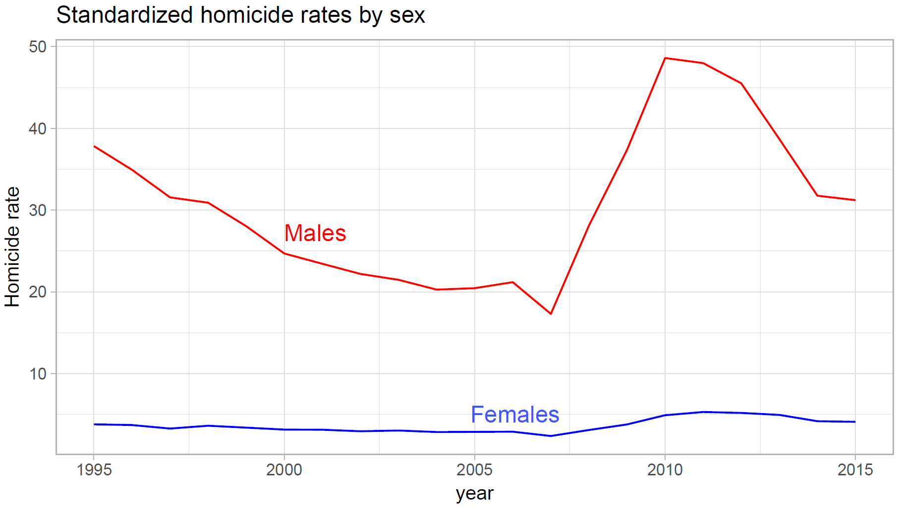

Figures S2 and S3 shows age- and cause-specific contributions (in years) to life expectancy and lifespan inequality’s changes at age 15 between 1995 and 2005 (Panels A) and between 2005 and 2015 (Panels B). Vertical values in rectangles next to the y-axis represent age-specific contributions, while bars’ length correspond to cause-specific contributions by age. Overall cause-specific contributions across all ages are shown in the panel’s legend in parenthesis (also in years).

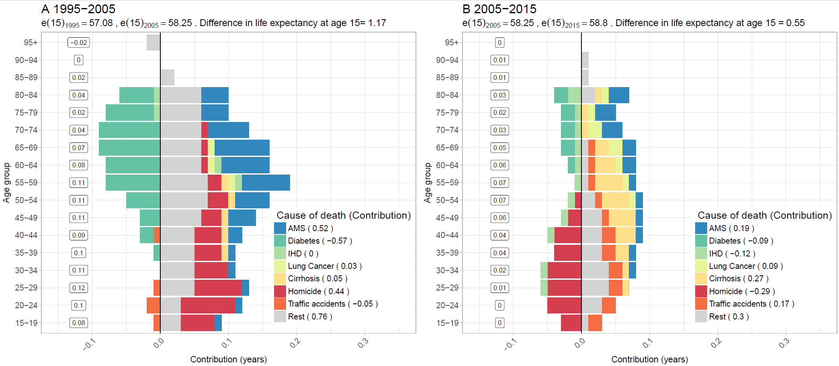**Figure S2 A. Age-cause specific contributions to the changes in national life at age 15 for Males. Panel A refers to 1995-2005 and panel B to 2005-2015. Note: Numbers in boxes are age-specific contributions.**

**Figure S2 B. Age-cause specific contributions to the changes in national lifespan inequality at age 15 for Males. Panel A refers to 1995-2005 and panel B to 2005-2015. Note: Numbers in boxes are age-specific contributions.**

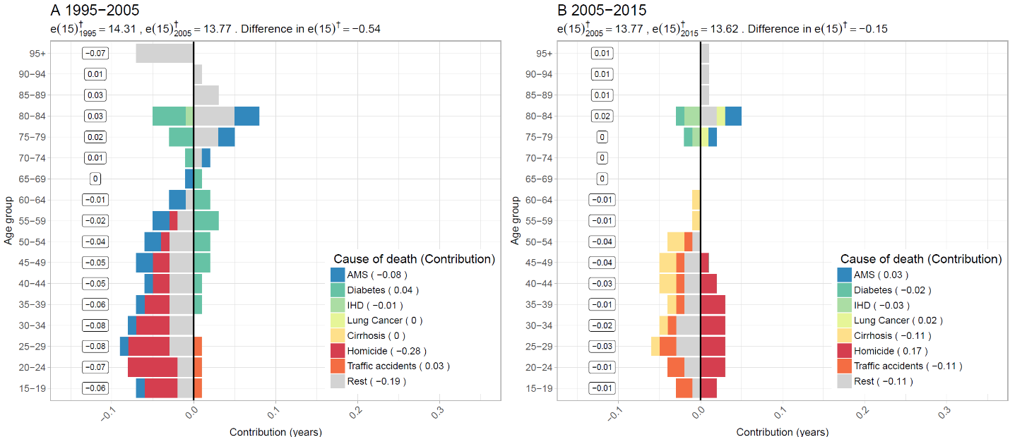

**Figure S3 A. Age-cause specific contributions to the changes in national life expectancy for females. Panel A refers to 1995-2005 and panel B to 2005-2015. Note: Numbers in boxes are age-specific contributions.**

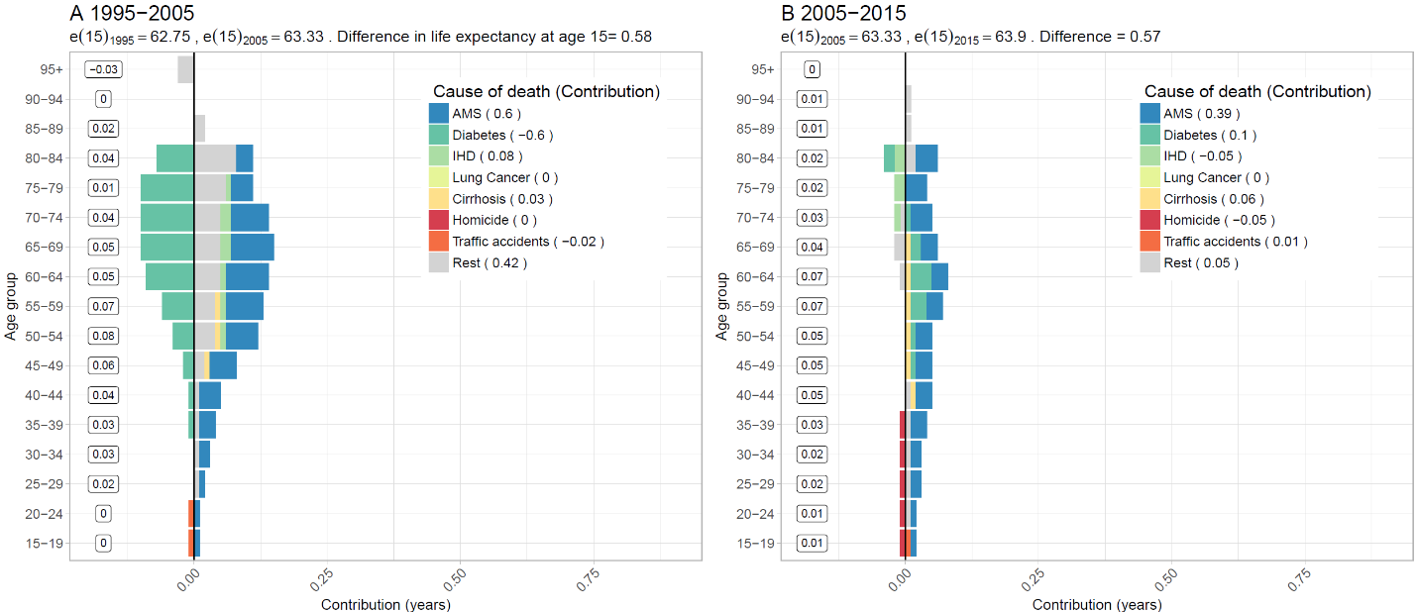

**Figure S3 B. Age-cause specific contributions to the changes in national lifespan inequality for females. Panel A refers to 1995-2005 and panel B to 2005-2015. Note: Numbers in boxes are age-specific contributions.**

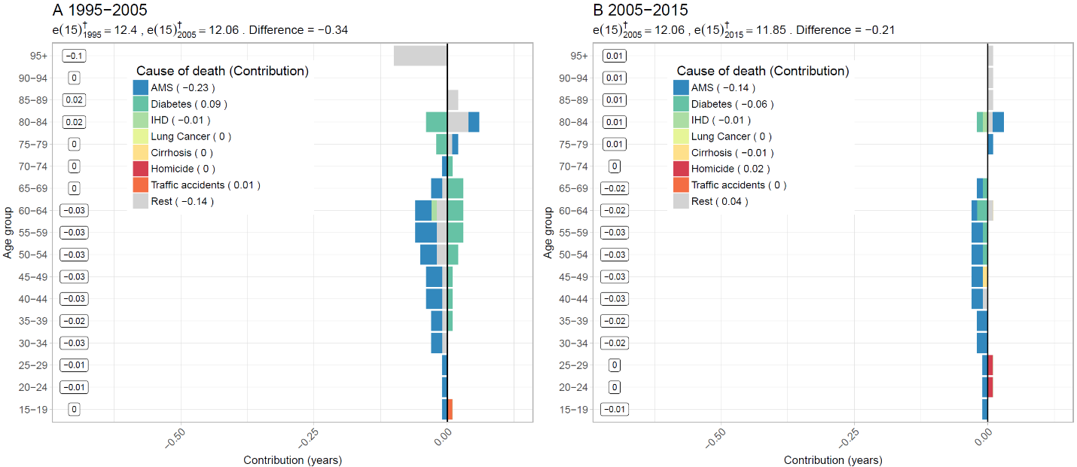

**Figure S4. Changes in female life expectancy (panel A) and male lifespan inequality (panel B)**

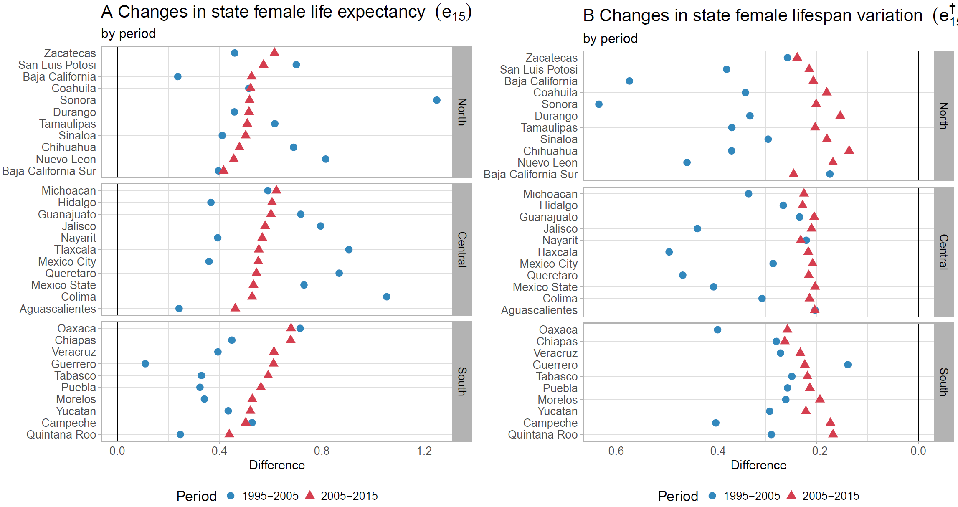**by state for the periods 1995-2005 and 2005-2015.**

**Figure S5. Cause-specific contributions to changes in male lifespan inequality at age 15 by state for the periods 1995-2005 and 2005-2015 (x-axis in different scale than the paper).**

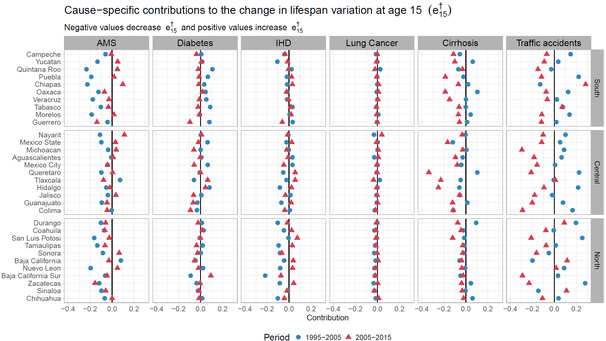

**Figure S6. Cause-specific contributions to changes in female lifespan inequality at age 15 by state for the periods 1995-2005 and 2005-2015.**

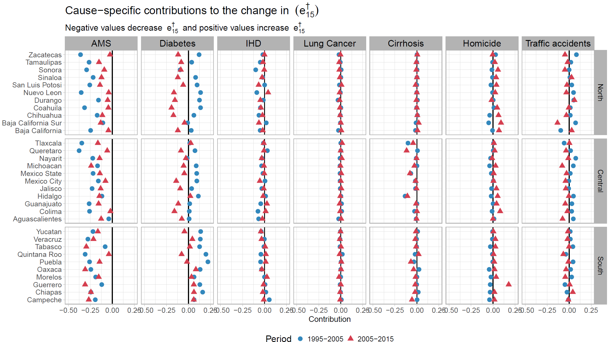

**Figure S7. Homicide contributions to changes in male life expectancy at age 15 by state for the periods 1995-2005 and 2005-2015.**

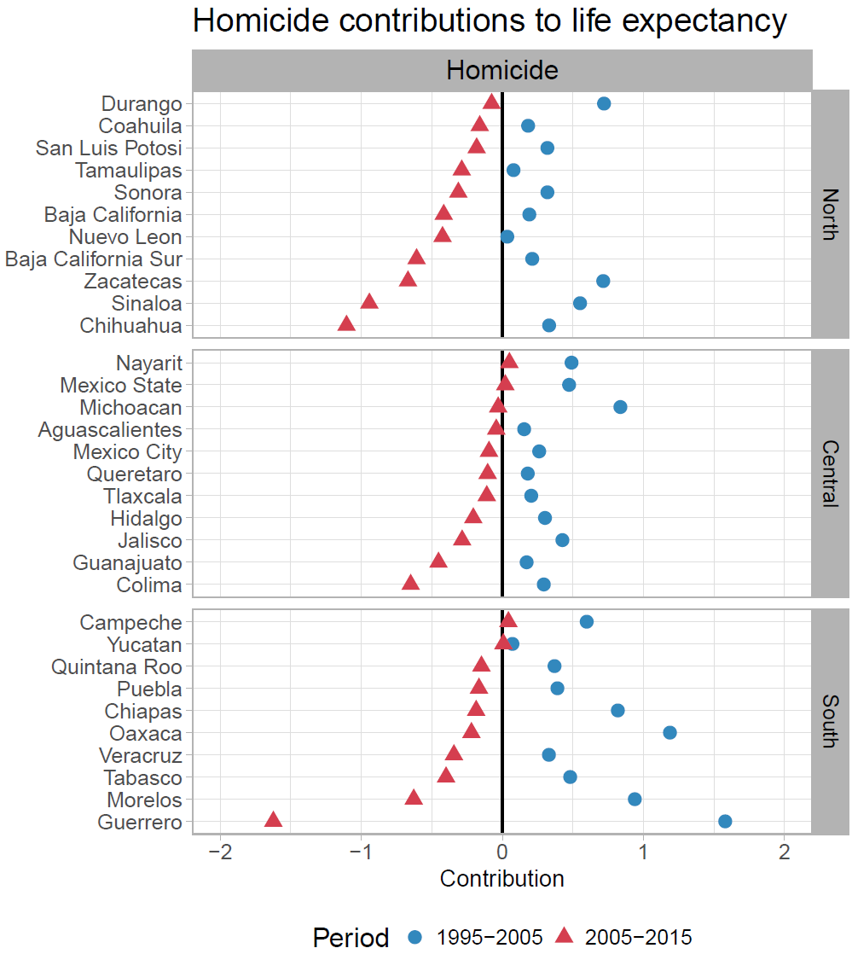

**References**

CONAPO. (2017). Mexican Population Council: Population estimates. Retrieved from <https://datos.gob.mx/busca/dataset/activity/proyecciones-de-la-poblacion-de-mexico>

INEGI. (2017). National Institute of Statistics: Micro-data files on mortality data 1995-2015. Retrieved from <http://www.beta.inegi.org.mx/proyectos/registros/vitales/mortalidad/default.html>